**NAME** :- Manish Shashikant Jadhav

**UID** :- 2023301005.

**BRANCH** :- Comps -B. **BATCH:** B.

**EXPERIMENT 7: To perform aggregate function, group by and having clause for university database.**

**SUBJECT** :- DBMS (DATABASE MANAGEMENT SYSTEM)

1. **Count:**

**Query:**

SELECT dept_name, COUNT(*) AS num_courses

FROM course

GROUP BY dept_name;

**Output:**



1. **Sum:**

**Query:**

SELECT SUM(budget) AS total_budget

FROM department;

**Output:**



1. **Avg:**

**Query:**

SELECT AVG(salary) AS avg_salary

FROM instructor

WHERE dept_name = 'Comp. Sci.';

**Output:**



1. **Max:**

**Query:**

SELECT building, MAX(capacity) AS max_capacity

FROM classroom

GROUP BY building;

**Output:**

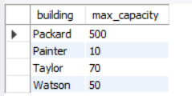

1. **Min:**

**Query:**

SELECT dept_name, MIN(credits) AS min_credits,

MAX(credits) AS max_credits

FROM course

GROUP BY dept_name;

**Output:**



**Group by Having clause:**

**1) List departments with an average instructor salary greater than $70,000.**

**2) Show courses with an average grade greater than or equal to 'B' (grade code).**

**3) List instructors who have taught at least 2 courses.**

**4) Find departments with an average budget greater than $80,000.**

**Query 1:**

SELECT dept_name, AVG(salary) AS avg_salary

FROM instructor

GROUP BY dept_name

HAVING AVG(salary) > 70000;

**Output:**

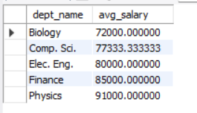

**Query 2:**

SELECT course_id, AVG(CASE WHEN grade >= 'B' THEN 1 ELSE 0 END)

AS avg_grade

FROM takes

GROUP BY course_id

HAVING avg_grade >= 0.8;

**Output:**

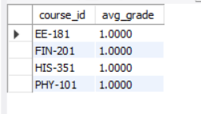

**Query 3:**

SELECT ID, COUNT(*) AS num_courses_taught

FROM teaches

GROUP BY ID

HAVING num_courses_taught >= 2;

**Output:**



**Query 4:**

SELECT dept_name, AVG(budget) AS avg_budget

FROM department

GROUP BY dept_name

HAVING AVG(budget) > 80000;

**Output:**

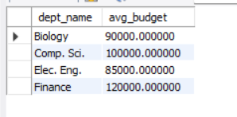

**Conclusion:** Hence by completing this experiment I cameto perform aggregate function, group by and having clause for university database.